#include<iostream>

using namespace std;

int S (int n)

{

if(n==1){

return n;

}else{

return n+ S(n-1);

}

}

int main()

{

int n,i, total=0;

cout<<"masukan bilangan deret : ";cin>>n;

for (i=1;i<n;i++)

{

if(i==1)

cout<<i;

else

cout<<"+"<<i;

}

cout<<"="<<S(n)<<endl;

return 0;

}

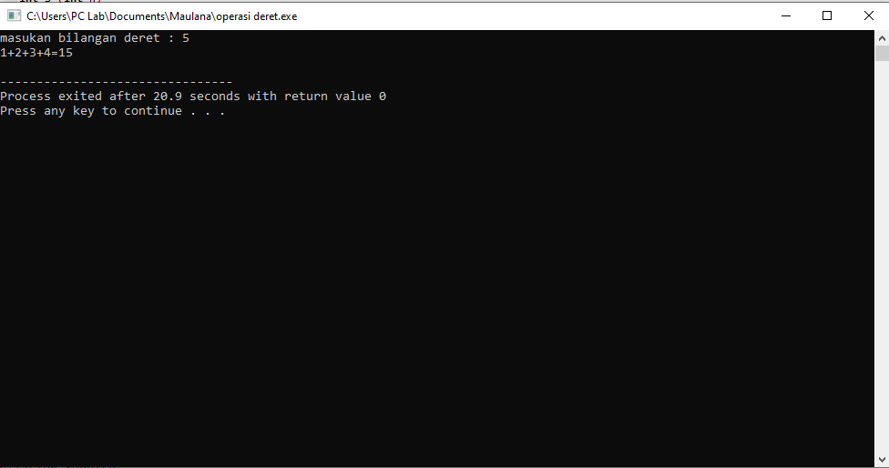

#include<iostream>

using namespace std003B

int S (int n)

{

if(n==1){

return (2);

}else{

return (2\*n + S(n-1));

}

}

int main()

{

int n,i, total=0;

cout<<"masukan bilangan deret : ";cin>>n;

for (i=2;i<=2\*n;i+=2)

{

if(i==2)

cout<<i;

else

cout<<"+"<<i;

}

cout<<"="<<S(n)<<endl;

return 0;

}

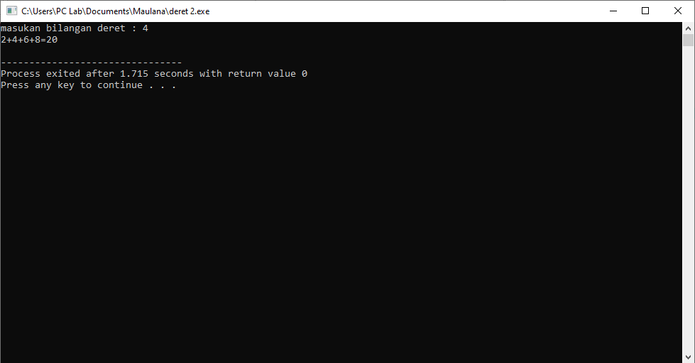

#include<iostream>

using namespace std;

int S (int n)

{

if(n==1){

return (1);

}else{

return (2\*n + S(n-1));

}

}

int main()

{

int n,i, total=0;

cout<<"masukan bilangan deret : ";cin>>n;

for (i=1;i<=2\*n;i+=2)

{

if(i==1)

cout<<i;

else

cout<<"+"<<i;

}

cout<<"="<<S(n)<<endl;

return 0;

}

